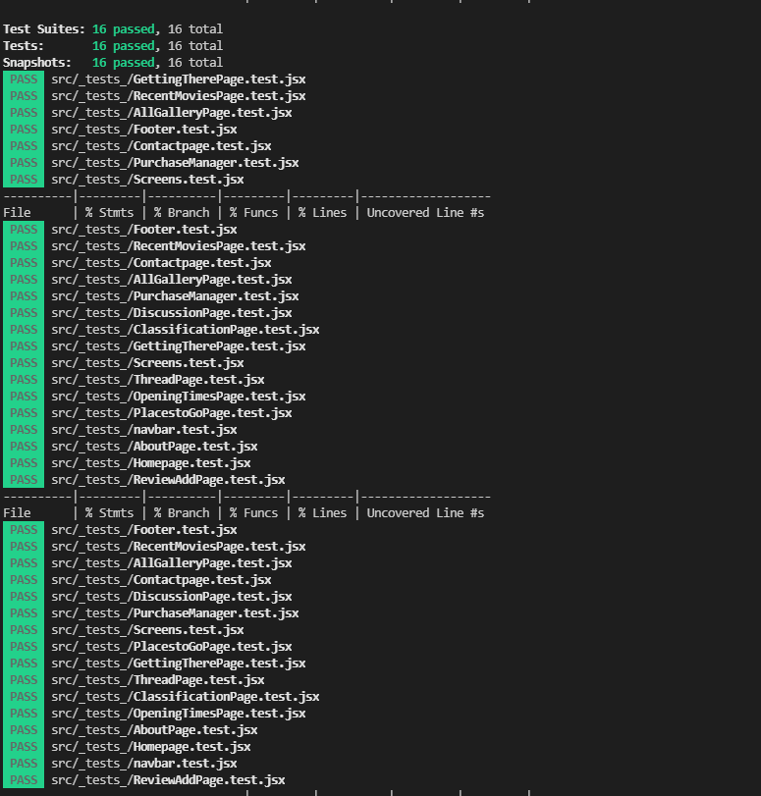**Testing Screenshots- Implemented & Running Tests (JEST)**

**Testing Coverage Screenshots- Utilised Istanbul for Test Coverage**

